## Merchant Name Themis Implementation POC: Arjun CX POC: Charlie

### 

### 

| Notes Sections   *(AE to fill if they have, Implementation to be completion DRI on handoff)*   * Info on how merchant bills Merchant bills recurring subscription plus implementation fee * What is the merchant temperament?   Very excited to work with us and use Tabs - main POC Ashley Summers, Neepa Patel is CEO but will likely be uninvolved   * What are the Tabs features that the key POC cares about?   Automation of billing, rev rec, etc. Their process  **Current Challenges:**   * Managing billing across HubSpot, Google Docs, QuickBooks, and spreadsheets, leading to inefficiencies and errors. * Simplifying revenue recognition, contract renewals, and partner payouts.   **How Tabs Can Help:**   * Automating the contract-to-cash workflow to reduce manual inputs. * Centralizing invoicing, GAAP/non-GAAP reporting (ARR, MRR), and collections. * Streamlining renewals with AI and automating partner payouts with remittances. |
| --- |

### Billing model *(Entire Section: Implementation to fill section)*

* Are there unique things about the customer creation process for this merchant?

Nothing special. Feel free to create a customer as needed.

* Information on how merchant bills

Recurring SaaS plus implementation

* How contract is broken up

* One off things to know about the merchant

### Contract Processing Steps *(Entire Section: Implementation/Success to fill Post-Go Live)*

1. Steps to process  
   Sometimes they upload NDAs and other docs that have no billing info. Feel free to mark those as processed without adding any billing terms.  
     
   For a Statement of Work, go to the Fees section and look for the breakdown of Fees and the Payment Schedule.

* If the Payment schedule is up-front annual (which is most common), you can create Billing Terms and Revenue Schedules off of the Fees section. There is often a discount which can be entered as a % or $ as needed.
* Sometimes the payment schedule does not cleanly fit with the monthly subscription. In these cases, feel free to skip the fees section and just reproduce the payment schedule. The discount % numbers may be rounded, in which case you can use only the subtotals which should be correct. If there’s uncertainty, feel free to escalate in the internal slack channel.

1. Anything to ignore in contracts?  
   If there is a payment schedule, you can ignore the standard price, discount, and final price, and can instead just create billing terms for the payment schedule.  
     
   This customer wants to see revenue go up progressively, so each billing term should have its own revenue schedule covering the time period that it pertains to. For example, the following contract should have 3 billing terms for $48,000 billed Jan 20 2024 (revenue recognized Jan 20, 2024-Jul 19, 2024), $37,500 billed Jan 20, 2024 (revenue recognized Jul 20, 2024-Jan 19, 2025), and $75,000 billed Jan 20, 2025 (revenue recognized Jan 20, 2024-Jan 19, 2025).  
     
   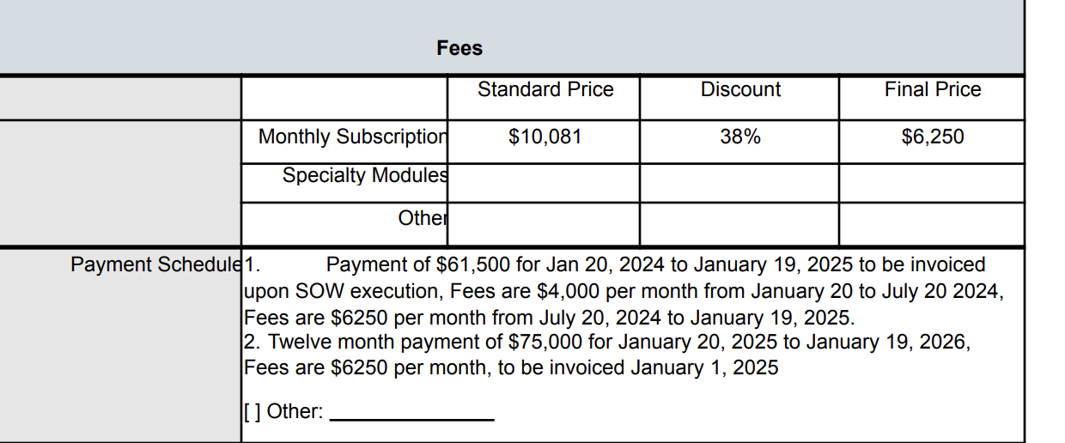  
     
   Ignore other elements in the contract like referral credits. There is no usage based billing for this merchant.
2. Specifics processing things the merchant has requested that may differ by contract (e.g. always back-date invoice date to final day of the month)  
     
   None
3. Default Service Term  
     
   12 month
4. Default Net Payment Terms

Net 30

1. Default Billing Frequency

Annual

1. How do we handle taxes as a line item?

No taxes

### Events Processing (if necessary) *(Entire Section: Implementation/Success to fill Post-Go Live)*

* None

Integration Items Processing (if necessary)  
*(Entire Section: Implementation/Success to fill Post-Go Live)*

* All subscription items should be assigned to “Subscription to Themis”
* One-off items at the start of a relationship should be assigned to “Implementation Fee - One Time”

Post Processing Communications (if necessary)  
*(Entire Section: Implementation/Success to fill Post-Go Live)*

* None

### Customer Information *(Entire Section: Implementation/Success to fill Post-Go Live)*

* None

### Feature Requests *(AE to fill for all requests prior to Imp handoff, Imp to fill prior to go-live/Success to fill to fill Post-Go Live)*

* None

### Merchant Calls *(AE to fill for all videos prior to Imp involvement, Imp to fill prior to go-live/Success to fill to fill Post-Go Live)*

* <https://www.loom.com/share/b0aae06ae8a0470184e5279812803b11?sid=59e87963-5aeb-48b7-b8ab-afab25f7ae44>